21. Randomly split iris dataset into train/test (80/20), build logistic regression (Species ~ Petal.Length + Petal.Width), predict, and evaluate with confusion matrix.

Aim: To randomly split iris dataset into train/test (80/20), build logistic regression (Species ~ Petal.Length + Petal.Width), predict, and evaluate with confusion matrix.

Procedure: Open RStudio.
2.Load the built-in iris dataset.
3.Randomly divide the dataset into 80% training data and 20% testing data.
4.Load the nnet package and build a multinomial logistic regression model.
5.Predict the species using the testing data.
6.Create a confusion matrix and calculate accuracy.

R Program:

# Question 21: Logistic Regression

data(iris)

# Split dataset into training and testing data
set.seed(123)
index <- sample(1:nrow(iris), 0.8 * nrow(iris))

train_data <- iris[index, ]
test_data <- iris[-index, ]

# Install once if needed:
# install.packages("nnet")
library(nnet)

# Build logistic regression model
model <- multinom(
Species ~ Petal.Length + Petal.Width,
data = train_data,
trace = FALSE
)

# Predict species
predictions <- predict(model, newdata = test_data)

# Confusion matrix
cm <- table(
Actual = test_data$Species,
Predicted = predictions
)
print(cm)

# Calculate accuracy
accuracy <- mean(predictions == test_data$Species) * 100
cat("Accuracy:", round(accuracy, 2), "%\n")
output:
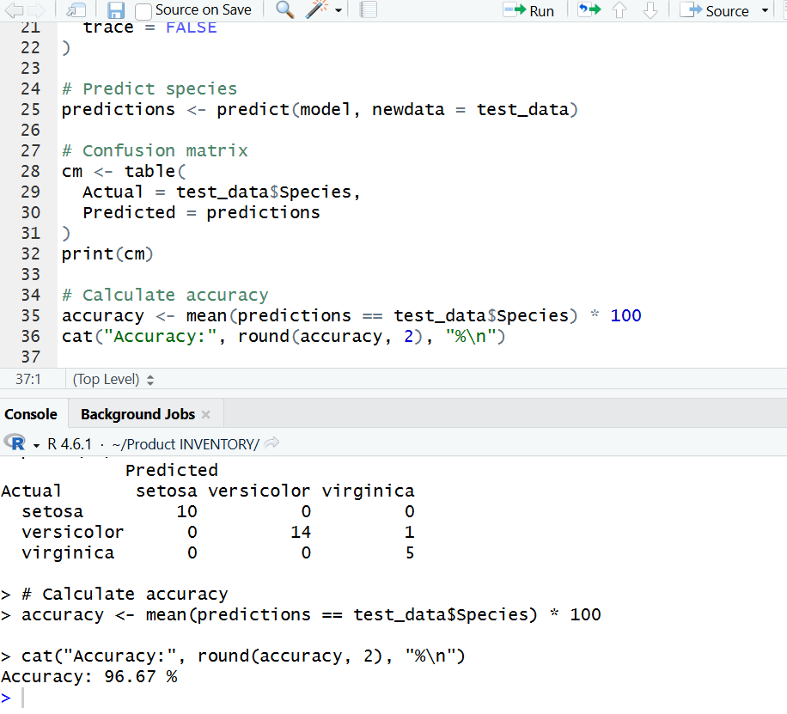

Lab Practice Questions

1. If-Else, Arithmetic and Boolean Operators
Aim: To check whether a number is positive, negative, or zero and demonstrate arithmetic and Boolean operators.
Procedure:
- Assign a number to a variable.
- Use if-else to identify its sign.
- Perform arithmetic operations on two numbers.
- Apply Boolean comparisons and print the results.
R Program:

num <- 5

if (num > 0) {
result <- "Positive"
} else if (num < 0) {
result <- "Negative"
} else {
result <- "Zero"
}

a <- 10
b <- 3

print(result)
print(a + b)
print(a - b)
print(a * b)
print(a / b)

print(a > b)
print(a == b)
print(a != b)
Output:
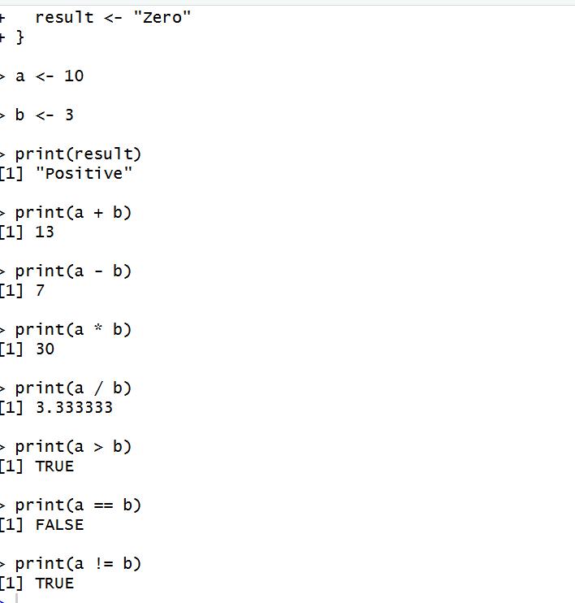

2. For Loop – Multiplication Table
Aim: To print the multiplication table of a number using a for loop.
Procedure:
- Assign a number.
- Use a for loop from 1 to 10.
- Multiply the number by each loop value.
- Display the multiplication table.
- Calculate the sum of numbers from 1 to 10.

R Program:

num <- 5

for (i in 1:10) {
cat(num, "*", i, "=", num * i, "\n")
}

total <- 0
for (i in 1:10) {
total <- total + i
}

cat("Sum from 1 to 10 =", total, "\n")

Output:
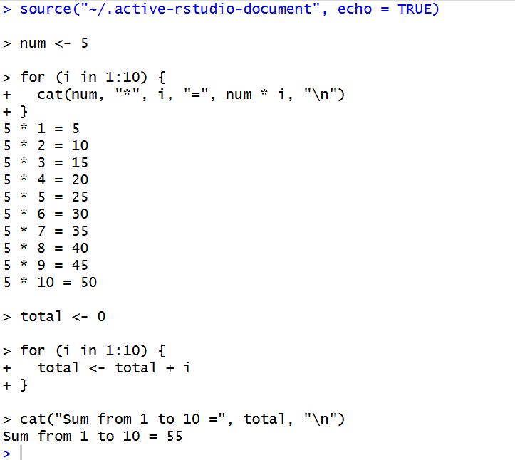

3. While Loop – Sum of Digits
Aim: To calculate the sum of digits of a number using a while loop.
Procedure:
- Assign a number.
- Extract the last digit using %%.
- Add the digit to the sum.
- Remove the last digit using %/%.
- Repeat until the number becomes zero.
R Program:

num <- 1234
total <- 0

while (num > 0) {
digit <- num %% 10
total <- total + digit
num <- num %/% 10
}

print(total)

Output:
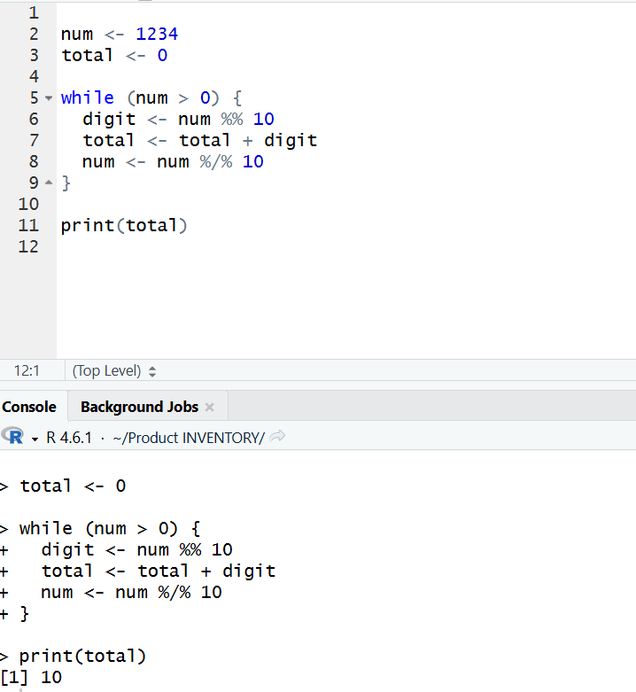
4. Control Statements – break and next
Aim: To demonstrate the use of break and next statements in loops.
Procedure:
- Start a for loop from 1 to 10.
- Use next to skip the value 3.
- Use break to stop the loop when the value reaches 8.
- Print the remaining values.
R Program:

for (i in 1:10) {
if (i == 3) {
next
}

if (i == 8) {
break
}

print(i)
}
Output:
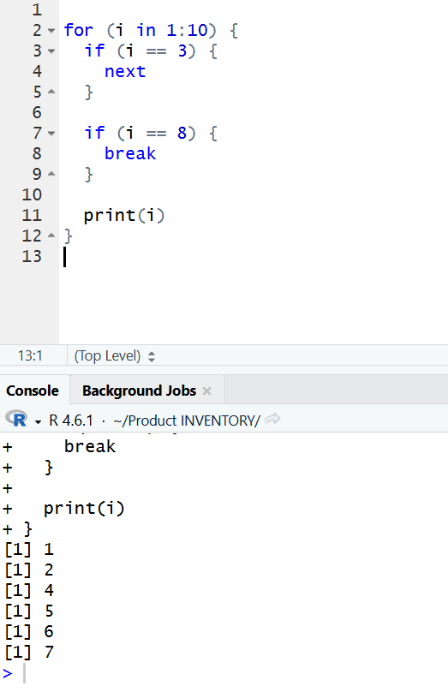

5. Looping Over a List
Aim: To create a list and access its elements using a loop.
Procedure:
- Create a list containing three values.
- Use a for loop to print the values.
- Extract the names of the list elements.
- Display each name with its corresponding value.
R Program:

my_list <- list(a = 10, b = 20, c = 30)

for (item in my_list) {
print(item)
}

names_list <- names(my_list)

for (name in names_list) {
cat(name, "=", my_list[[name]], "\n")
}

Output:
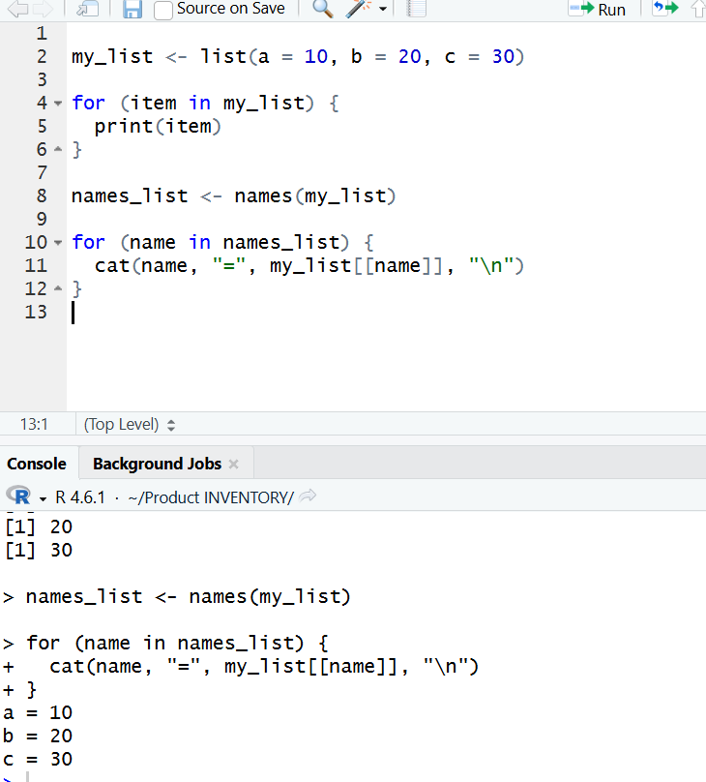

6. Function with Default Argument Values
Aim: To create and use an R function with a default argument value.
Procedure:
- Define a function with two arguments.
- Assign a default value to the second argument.
- Call the function with one argument.
- Call the function again with both arguments.
- Display the results.
R Program:

add_numbers <- function(a, b = 10) {
result <- a + b
return(result)
}

print(add_numbers(5))
print(add_numbers(5, 20))
Output:
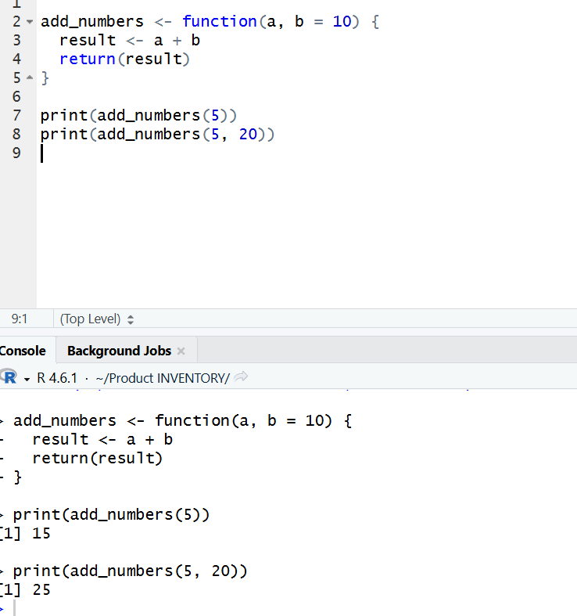
7. Return Values and Explicit return()
Aim: To demonstrate implicit and explicit return values in R functions.
Procedure:
- Create a function to calculate the square of a number.
- Return the result implicitly as the last expression.
- Create another function to calculate the cube.
- Use return() explicitly.
- Print both results.
R Program:

# Implicit return
square_number <- function(x) {
x * x
}

# Explicit return
cube_number <- function(x) {
return(x * x * x)
}

print(square_number(4))
print(cube_number(3))
Output:
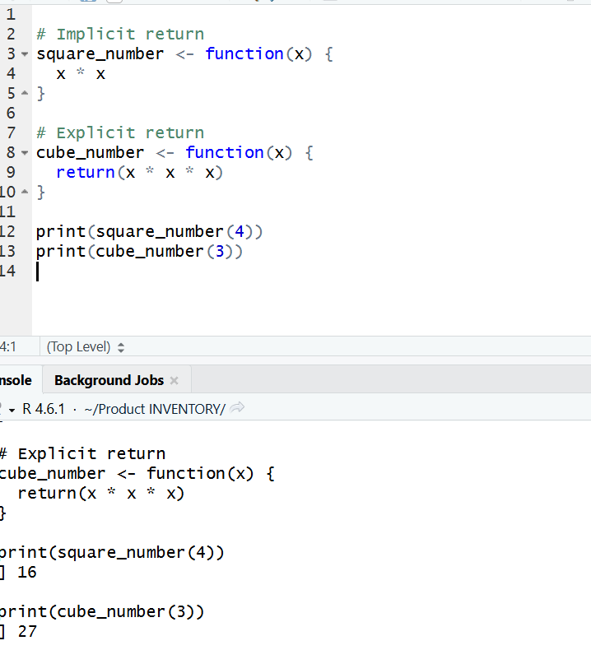

8. Returning Multiple Values Using a List
Aim: To create a function that returns multiple statistical values using a list.
Procedure:
- Define a function that accepts a numeric vector.
- Calculate the sum, mean, maximum, and minimum.
- Store the results in a list.
- Return and display the list.
R Program:

calculate_stats <- function(x) {
result <- list(
sum = sum(x),
mean = mean(x),
max = max(x),
min = min(x)
)

return(result)
}

data <- c(10, 20, 30, 40)
stats <- calculate_stats(data)

print(stats)

output:
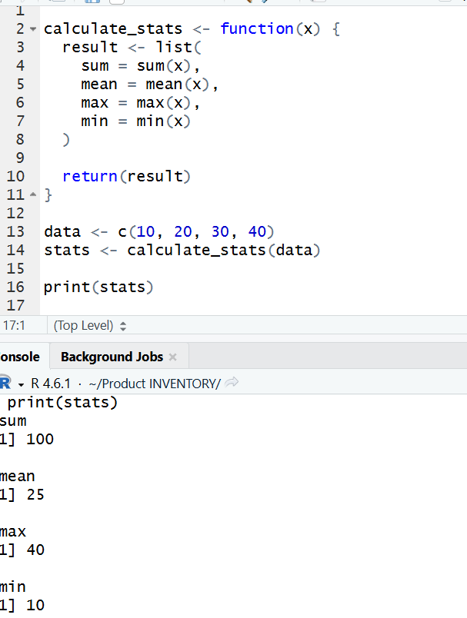

9. Functions Are Objects in R
Aim: To demonstrate that functions can be stored in variables and called using different names.
Procedure:
- Define a function that adds 1 to a number.
- Display the function's class.
- Call the function.
- Assign the function to another variable.
- Call the function using the new variable.
R Program:

my_function <- function(x) {
x + 1
}

print(class(my_function))
print(my_function(10))

another_function <- my_function
print(another_function(20))

Output:
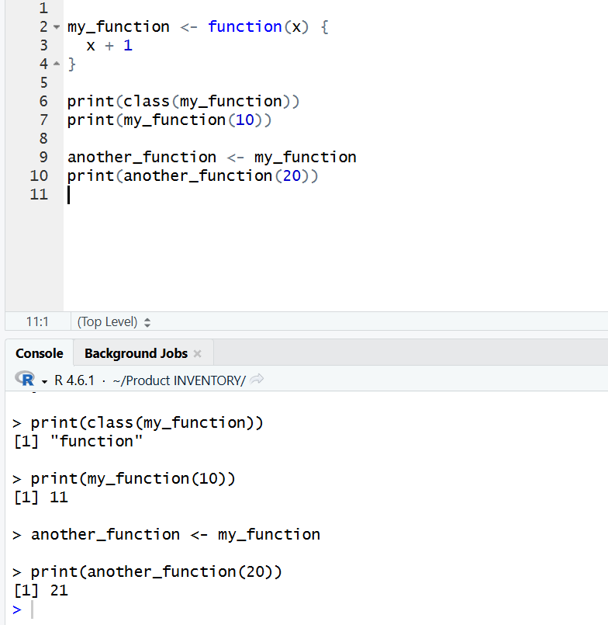

10. Recursion – Factorial Program
Aim: To calculate the factorial of a number using a recursive function.
Procedure:
- Define a recursive function.
- Set the base case for 0 or 1.
- Multiply the number by the factorial of the previous number.
- Call the function with a number.
- Display the result.
R Program:

factorial_fun <- function(n) {
if (n < 0 || n != floor(n)) {
stop("Enter a non-negative integer")
}

if (n == 0 || n == 1) {
return(1)
} else {
return(n * factorial_fun(n - 1))
}
}

print(factorial_fun(5))
Output:
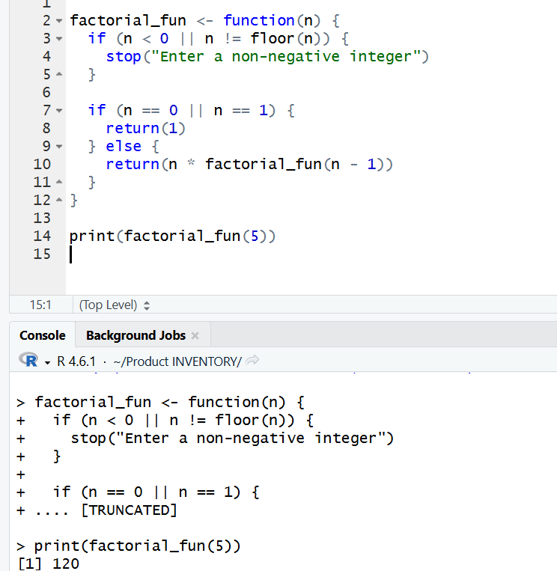

11. Fibonacci Series Using Recursion
Aim: To generate the Fibonacci series using a recursive function.
Procedure:
- Define a recursive Fibonacci function.
- Return 0 when the input is 0.
- Return 1 when the input is 1.
- For other values, add the previous two Fibonacci values.
- Use a loop to display the first 10 terms.
R Program:

fibonacci <- function(n) {
if (n == 0) {
return(0)
} else if (n == 1) {
return(1)
} else {
return(fibonacci(n - 1) + fibonacci(n - 2))
}
}

n <- 10

cat("Fibonacci Series:\n")

for (i in 0:(n - 1)) {
cat(fibonacci(i), " ")
}

cat("/n”)

Output:
